PREVENTION OF SEXUAL HARASSMENT (POSH)
ORIENTATION PROGRAM
PROGRAM: Orientation for First year students
DATE & TIME: 19.09.2025 & 03.00P.M. - 04.00 P.M
VENUE: Seminar Hall
The internal complaints cell of OASYS Institute of Technology organised an Orientation program for fresher’s regarding the prevention of sexual harassment in the workplace on the 19th of September 2025, from 3.00 pm to 4.00 pm, at ground floor seminar hall, as a part of the orientation program for new students.
Mrs.S.Nishanthinivalli, POSH, Coordinator, welcomed the new batch of students and explained the importance of the POSH cell and the working of the internal complaints cell. She enlightened the students about fostering a culture of dignity and respect, and a sexual harassment and exploitation-free environment here at OASYS Institute of Technology. She further explained the complaint registering process in detail, and assured the students that their confidentiality will always be protected at such cases.
Around 190 first year girl students and 30 female faculties participated and benefitted from the event.
Objectives:
- To educate the newly joined students and faculty about the POSH Act, its implications, and the importance of preventing sexual harassment.
- To explain the policy of how the POSH cell works.
- To outline the complaint process to the students.
Outcomes:
- Students and faculty understood the POSH Act, its implications, and the importance of preventing sexual harassment.
- The Participants comprehend the college's POSH policy, including the roles and responsibilities of the POSH cell.
- The Students had a clear understanding of how to report incidents of sexual harassment and the steps involved in the complaint process.
Conclusion:
The program was a great success which leads towards creating a safe, inclusive, and respectful environment for all students and faculty at OASYS Institute of Technology.
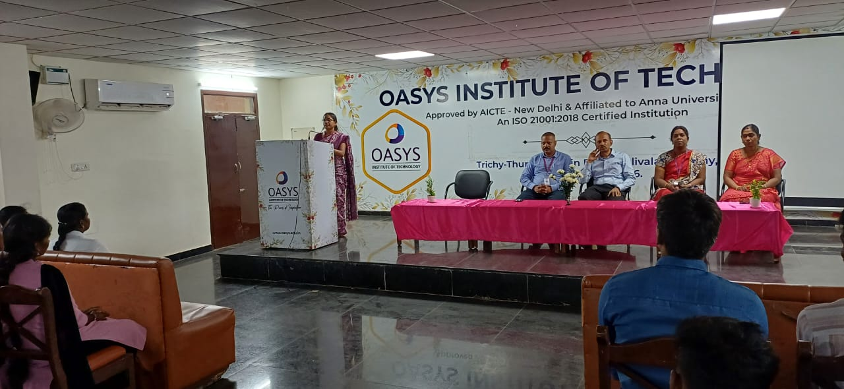 | 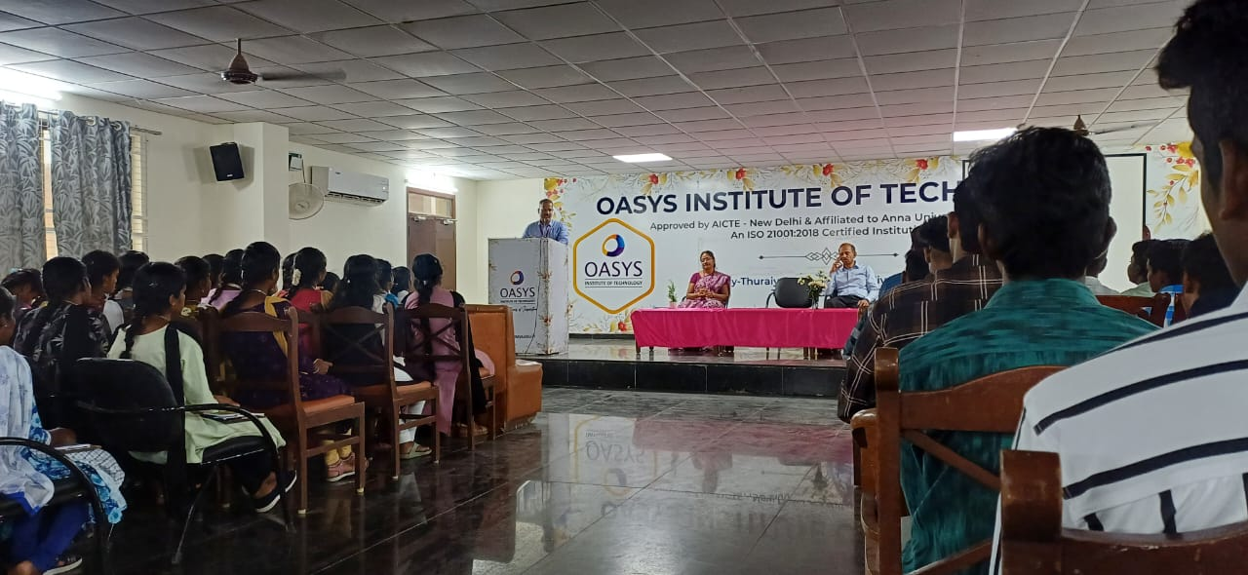
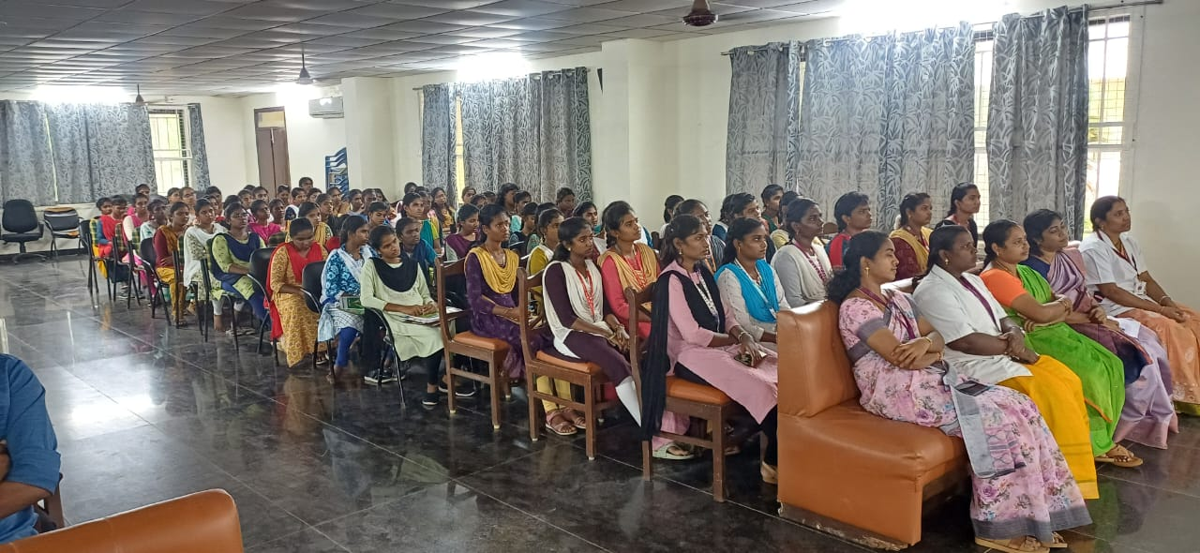 | 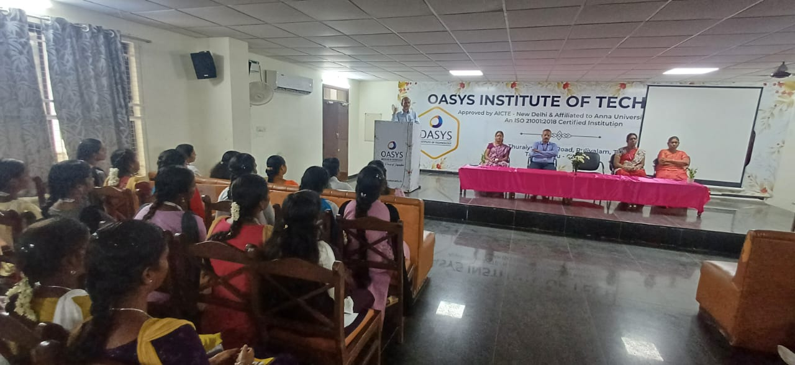

POSH Coordinator Director IQAC Principal

PREVENTION OF SEXUAL HARASSMENT (POSH)
ORIENTATION PROGRAM
(Academic Year 2025-26)

S.No | Name of The Event | Date & Time | Venue | Participation Details
1 | Orientation program for fresher’s students | 19.09.2025 / 03.00P.M. -04.00 P.M | Seminar Hall | Ist year Girl’s students
2 | POSH in Academia - Ensuring a Safe and Dignified Workplace, | 08.10.2025 / 03.00P.M. -04.00 P.M | Seminar Hall | All Female Faculty’s & All Girl’s students

POSH Coordinator Director IQAC Principal

PREVENTION OF SEXUAL HARASSMENT (POSH)
AWARENESS PROGRAMME
PROGRAM: POSH in Academia
DATE & TIME: 08.10.2025 & 03.00P.M. - 04.00 P.M
VENUE: Seminar Hall
An awareness programme on the topic of POSH in Academia - Ensuring a Safe and Dignified Workplace, was held on 8th of October 2025, between 03.00P.M. - 04.00 P.M, at ground floor seminar hall, on behalf of the POSH cell at OASYS Institute of Technology .
In this programme Mrs. S.Vennila,Manager, Mrs.B.Padmavathi, Block Co-ordinator &Mrs M.Kavitha,Trainer Tamilnadu state Rural Livelihoods Mission,Trichy as special guest. Mrs. S.Vennila, in her speech spoke about prevention and redressal of sexual harassment incidence at workplace and methods for resolving such complaints. She also spoke in detail about the sexual harassment of women at workplace act 2013 and the functions of area development offices. More than 80 people including professors, female employees and students of college and benefited from this event.
Objective:
- To educate participants about the POSH act, its implications and importance of preventing sexual harassment.
- To explain colleges POSH policy including the roles and responsibilities of the POSH cell.
- To encourage respectful behavior among students and faculty promoting a culture of dignity and respect.
Outcome:
- The participants understood the POSH act, its implications and importance of preventing sexual harassment.
- The participants understood the roles and responsibilities of the POSH cell and obtained clear idea about the complaint and redressal activity.
- The participants comprehended the necessity of dignity and respect among one another in the institution.
Conclusion:
The program was a great success among the participants. The participants acquired knowledge about sexual harassment of women at workplace act 2013 and the working of the POSH cell of OASYS Institute of Technology.
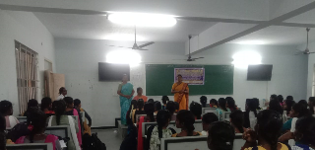

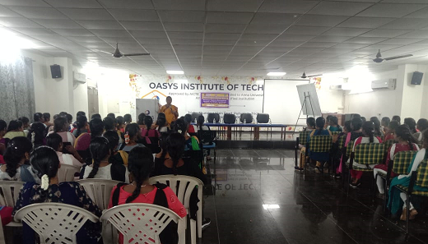

POSH Coordinator Director IQAC Principal

